ITAR or EAR Compliance Documentation Request & Annual Customer Profile

We believe your company probably does business in one of the following industries: Firearms, Aerospace or Government/Defense or Military. These trades are the most compliance laden industries that end up having closer scrutiny, when it comes to homeland security efforts.

The U.S.Government has established manufacturing and export compliance regulations to protect data and services of United States businesses from being dispersed to embargoed countries or foreign persons, etc. At this time we are requesting all of our prospects and customers in these industries, (regardless of intent to export the product) to provide compliance information for the part numbers being ordered so that we may continue to remain compliant in our processes and continue to provide you with the highest level of service.

This packet serves as our official request to obtain specific documentation regarding your company’s controlled products and the acknowledgement of the United States Government export compliance regulations. It is CSS’s policy to main a current copy of your DDTC registration on file with the registration code blacked out or a copy of your Federal Firearms License with the registration number present. (Please see page 5 for copies of our CSS DDTC & FFL registrations.

We ask at this time that you provide us with a copy of either the DDTC or FFL, so we can process all inquiries without delays.

The request for a current DDTC will be an annual request & the FFL will be every 3 years at the expiration date.

We are also requesting 2 pages of this packet be completed and returned to us, to complete your compliance file

- Please review and complete page 3 of the compliance packet. This Information Request Form will require either the USML or ECCN code of each of the controlled parts purchased. We cannot process your orders without this information.
- Please review and complete page 4 of the compliance packet, as we do not currently have the Annual customer Profile-Export Compliant document on file for your company.

Failure to provide these documents will only delay quoting and processing of purchase orders.

What is ITAR and EAR?

What is ITAR?  ITAR is the International Trade in Arms Regulations that incorporates various military items or defense articles & regulates goods and technologies designed to kill or defend in a military setting. It includes Aerospace & other space related technologies because of the application to missile technologies. This includes all related technical data/blue prints, etc. Strict regulatory licensing is required to ship such products. The items are broken down on the United States Munitions List (USML) and CSS will require a USML code to process such items.  How does ITAR apply to me?  The ITAR is applicable to any company involved in the manufacturing, sale/resale or assembly or distribution of goods or services covered under the USML or a component supplier of goods covered under the USML. The stipulation of being “ITAR” compliant means that the company must be registered with the Directorate of Defense Trade controls (DDTC) to participate in such activities. CSS requires a copy of this DDTC registration on file to process all ITAR applicable orders. | 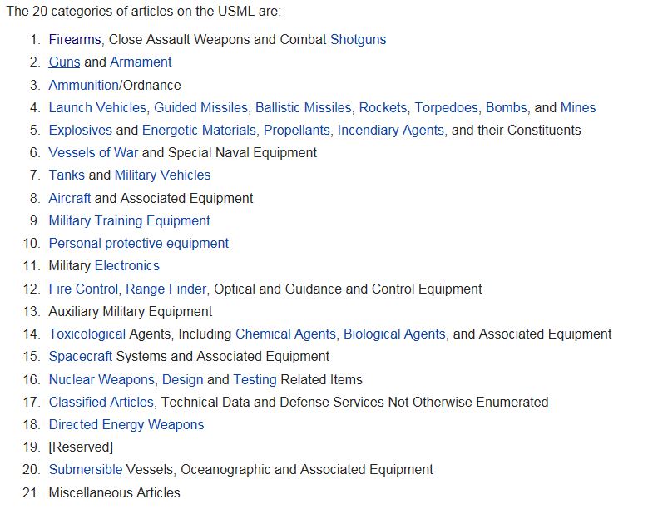
What is EAR?  EAR is the Export Administration Regulations that controls items designed for commercial purpose which could have military applications such as computer or software. The EAR covers both the goods and the technology. Licensing addresses competing interests and foreign availability of such items. The regulations also combine commercial and research objectives with national securities. The items controlled by the EAR are on the Commercial Control List (CCL) and CSS will require an Export Control Classification Number (ECCN) to process such items.  How does EAR apply to me?  The EAR is applicable to any company involved in manufacturing, sale/resale or assembly or distribution of goods or services covered under the Commerce Control List (CCL) or a component supplier of goods covered under the CCL. If the part is not on the list, it will be classified as EAR99 for a “NO License Required” status in the CSS manufacturing system. |  | 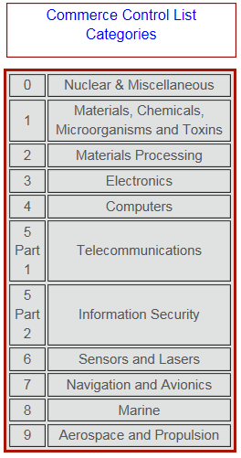

ITAR/EAR Information Request Form

The following parts require ITAR or EAR Controls. Please fill in the requested information, sign and return to CSS with your DDTC or FFL where applicable. You MUST specify USML or ECCN codes for each part number listed.
Company:
Address:
City: |  |  |  |  | State: |  |  |  |  | Country: |  |  | Zip:
Part Number |  | ITAR  Yes /No | (If ITAR)  USML# | EAR  Yes /No |  | (If EAR)  ECCN# |  |  | Application of Part(s) – what is it used in? |  |  | End Use:
Authorized Representative  (Typed Name/Title) |  |  |  |  |  |  | Authorized Signature |  |  |  |  |  |  | Date

Annual Customer Profile – Export Compliant

Please complete the following fields:

Company:
Address:
City: |  |  | State: |  | Country: |  | Zip:
Parent Company:
Other Affiliated Companies:

1. Has your company ever been suspended from doing business with the U.S. Government? |  |  |  |  |  | Yes No
If yes, please explain:
2. Is your company currently debarred or suspended from doing business with the U.S. Government? |  |  |  |  |  | Yes No
If yes, please explain:
3. Check only one:
 | My company has an Export Management and Compliance Program which safeguards restricted items from violating the U.S. Export Regulations, including illegal exporting and deemed exports.
 | Compliance Contact: |  |  | Email:
 | My company does not have an Export Management and Compliance Program.
 | If this does not apply to your company, please indicate this by checking here, then return the form to the address below with a brief explanation for our records. (Example: Our firm only manufactures screws and bolts, which are not restricted in any way by ITAR or EAR.)
4. Check only one:
All of my company’s personnel (including employees, consultants, or outside contractors) meet the definition of a U.S. Person.
U.S. Person: A natural person who is a lawful permanent resident as defined in 8 U.S.C. 1101(a)(20) or who is a protected individual as defined by 8 U.S.C. 1324(a)(3). It also means any corporation, business association, partnership, society, trust, or any other entity, organization or group that is incorporated to do business in the U.S. It also included any governmental (federal, state or local), entity.
 | My company utilizes personnel (including employees, consultants, or outside contractors) who do not meet the definition of a U.S. person.
 | (NOTE: If this box is checked, please explain how your company prohibits Foreign Persons from accessing restricted items.)
Authorized Representative  (Typed Name/Title) |  |  | Authorized Signature |  |  |  | Date

Please return completed form by email, fax or mail:

Attention: Gia L. Zarrella, Director of Compliance
Email: Gia@ctspring.com
Phone: 860.703.1650 Fax: 860.677.7199

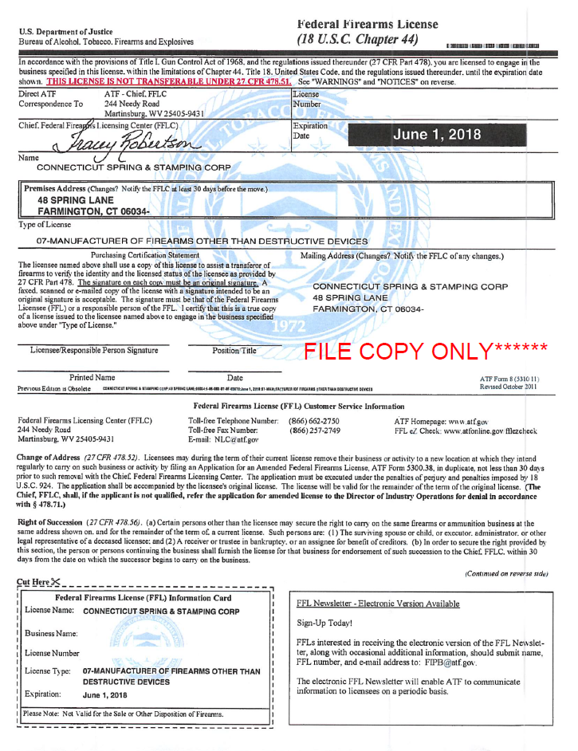
CSS DDTC and FFL

