International Export Compliance Information Request-EAR Controlled Products

We are excited about the chance of working with you and your company and are enthusiastic about all the great possibilities!

To comply with U.S. Export Compliance Regulations, we must determine the classification of the parts you wish for us to quote or manufacture.

What is EAR?  EAR is the Export Administration Regulations that controls items designed for commercial purpose which could have military applications such as computer or software. The EAR covers both the goods and the technology. Licensing addresses competing interests and foreign availability of such items. The regulations also combine commercial and research objectives with national securities. The items controlled by the EAR are on the Commercial Control List (CCL) and CSS will require an Export Control Classification Number (ECCN) to process such items.  How does EAR apply to me?  The EAR is applicable to any company involved in manufacturing, sale/resale or assembly or distribution of goods or services covered under the Commerce Control List (CCL) or a component supplier of goods covered under the CCL. If the part is not on the list, it will be classified as EAR99 for a “NO License Required” status in the CSS manufacturing system. | 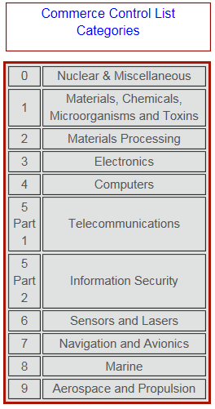

Part Number(s): |  | Application of Part(s) – what is it used in? |  |  | End Use:
Please advise which Commerce Control List Category:
If the part you are requesting IS on the list above, we will work with you to obtain additional information to accurately classify the parts. Once a purchase order is placed, we will request an End User Statement and Import/Export Declaration be submitted, so that we can apply for the export license.
If the part you are requesting CSS to quote is NOT on the list above we will classify them as EAR99 parts & once a Purchase Order is placed request a Letter of Assurance to complete the file.

Company:
Address:
City: |  | State: |  | Country: |  | Zip:
Name of Authorized Representative |  |  | Authorized Signature |  |  |  | Date

If you have a compliance person that you would like us to contact, please provide contact information below:
Name of Compliance Contact | Email | Date

Please select the industries(s) that best reflects your company:
Aerospace | *Automotive | *Consumer Products | *Electronics
Firearms | Govt/Defense | *Medical | *Office Products
Other (Please Describe):

* It is mutually understood you are advising CSS that there are NO ITAR or EAR controls imposed on any of your current products or planned future products. Please note it is your company’s sole responsibility to notify CSS immediately if ITAR or EAR controls become imposed on any of your products.

Please contact Gia L. Zarrella, our Director of Compliance at 860.703.1650 or gia@ctspring.com for any questions or concerns.

