International Export Compliance Information Request-ITAR Controlled Products

We are excited about the chance of working with you and your facility and are enthusiastic about the all the great possibilities!

While moving forward with the exchange of information regarding the products you would like for CSS to Quote and possibly fabricate, we must also remain compliant with the United States Export Control Regulations regarding ITAR compliance.

The U.S. Government has established export compliance regulations to protect technical data and defense services of United States businesses from being dispersed to embargoed countries or landing in foreign entities possession that is detrimental to U.S. homeland security.

In short, we must determine the classification of the parts you wish for us to quote or manufacture for us. If it is found to be a controlled item on the United States Munitions List, it will alert us to prepare an application for the required export license, so we can export these products.

What is ITAR?  ITAR is the International Trade in Arms Regulations that incorporates various military items or defense articles & regulates goods and technologies designed to kill or defend in a military setting. It includes Aerospace & other space related technologies because of the application to missile technologies. This includes all related technical data/blue prints, etc. Strict regulatory licensing is required to ship such products. The items are broken down on the United States Munitions List (USML) and CSS will require a USML code to process such items.  How does ITAR apply to me?  The ITAR is applicable to any company involved in the manufacturing, sale/resale or assembly or distribution of goods or services covered under the USML or a component supplier of goods covered under the USML. The stipulation of being “ITAR” compliant means that the company must be registered with the Directorate of Defense Trade controls (DDTC) to participate in such activities. CSS requires a copy of this DDTC registration on file to process all ITAR applicable orders. | 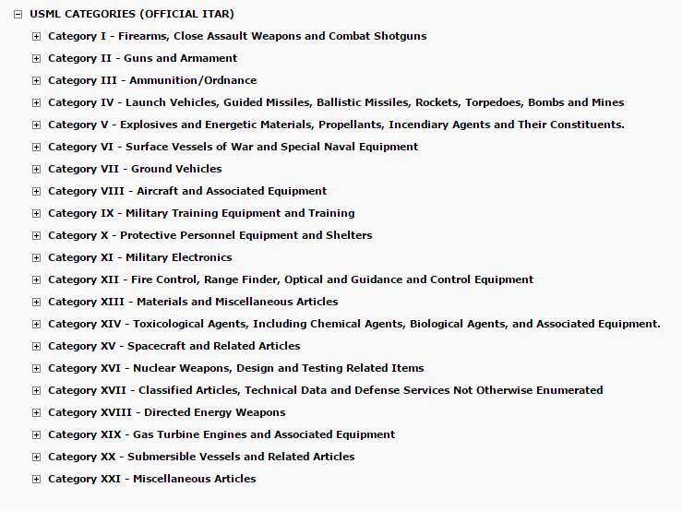

Part Number(s): |  | Application of Part(s) – what is it used in? |  |  | End Use:
Please advise which USML category:
If the part you are requesting IS on the list above, we will work with you to obtain additional information to accurately classify the parts. Once a purchase order is placed, we will request an End User Statement and Import/Export Declaration be submitted, along with the International Verification Information Form so that we can apply for the export license.

Company:
Address:
City: |  | State: |  | Country: |  | Zip:
Name of Authorized Representative |  |  | Authorized Signature |  |  |  | Date

If you have a compliance person that you would like us to contact, please provide contact information below:
Name of Compliance Contact | Email | Date

Please select the industries(s) that best reflects your company:
Aerospace | Automotive | Consumer Products | *Electronics
Firearms | Govt/Defense | Medical | *Office Products
Other (Please Describe):

Please contact Gia L. Zarrella, our Director of Compliance at 860.703.1650 or gia@ctspring.com for any questions or concerns.

